# **LLaMa 3 vs. Mistral 7B:**

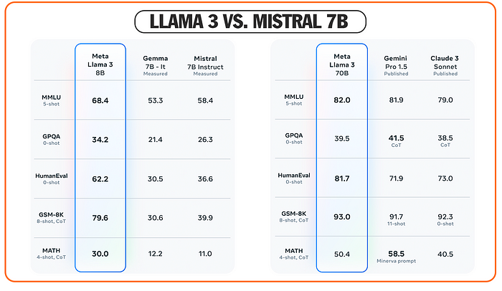

LLaMa 3 vs. Mistral 7B

****In artificial intelligence, two standout models are making waves: Meta’s LLaMa 3 and Mistral 7B.****LLaMa 3, with its advanced 8B and 70B parameter versions, sets a new standard for language models, offering unparalleled performance across numerous benchmarks and enhanced reasoning capabilities. It’s designed to inspire innovation in everything from app development to AI optimization. On the other hand, Mistral 7B brings a unique approach with its compact size yet powerful performance, making it adept at tasks ranging from text generation to coding assistance. Both models are poised to transform how we interact with technology, each in its own unique way.

# **Performance Comparison**

****LLaMa 3 has significantly advanced the state-of-the-art for large language models (LLMs) with its robust enhancements in pretraining and post-training techniques.****These enhancements have not only reduced errors and improved model alignment but have also boosted the diversity and quality of the model’s responses. LLaMa 3 excels in reasoning, code generation, and following complex instructions, making it a versatile tool for developers and researchers.

On the other hand, ****Mistral 7B, designed by Mistral AI, showcases its prowess in efficiently handling tasks that typically require larger models.**** Although smaller in size, Mistral 7B competes closely with larger models like LLaMa 3’s 8B in specific benchmarks, particularly in areas requiring intensive reasoning and code comprehension. This model achieves performance levels comparable to significantly larger models, suggesting an excellent cost-to-performance ratio.

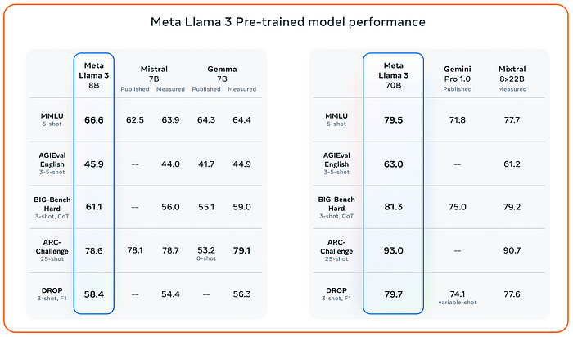

Notably, when compared directly, ****LLaMa 3’s 70B model stands out in more complex and diverse tasks, reflecting its advanced capabilities and larger scale.**** Mistral 7B, while slightly less robust in broad knowledge tasks due to its smaller size, still delivers competitive results, particularly in specialized benchmarks like coding and reasoning.

# **Key Features of LLaMa 3 and Mistral 7B**

## **LLaMa 3 Features:**

* ****Extensive Training Data:**** LLaMa 3 was trained with over 15 trillion high-quality tokens from public sources, which is seven times more than its predecessor, LLaMa 2. This massive amount of data helps the model understand and generate better responses.
* ****Enhanced Coding Data:**** The training included four times more coding data than before, improving its ability to handle programming-related tasks.
* ****Multilingual Support:**** More than 5% of LLaMa 3’s training data includes content in over 30 languages, preparing it for future versions that can understand multiple languages.
* ****Rigorous Data Filtering:**** The data used to train LLaMa 3 went through extensive checks to remove inappropriate content and duplicates, ensuring the model learns from the best quality data.

## **Mistral 7B Features:**

* ****Efficient and Powerful:**** Mistral 7B, with 7 billion parameters, is designed to be fast and effective, making it suitable for tasks that need quick responses.
* ****Advanced Attention Mechanisms:**** It uses special techniques like Grouped-Query Attention for quick processing and Sliding Window Attention for handling long pieces of text without using too much memory.
* ****High Performance:**** Despite its smaller size, Mistral 7B performs exceptionally well in tasks like math, coding, and logical thinking, even outdoing larger models.
* ****Fine-Tuning and Moderation:**** It is easy to adjust Mistral 7B for specific tasks like chatting or answering questions. It also has built-in safety features to prevent inappropriate outputs.
* ****Accessible and Open Source:**** Mistral 7B is available under a license that allows anyone to use it freely and can be accessed on popular AI platforms.

# **Mistral 7B vs. LLaMa 3: Comparing Architectures**

## **LLaMa 3 Architecture:**

* ****Architecture:**** LLaMa 3 keeps a similar basic structure to LLaMa 2, using a decoder-only transformer setup. This means it primarily focuses on generating text based on what it has learned.
* ****Tokenizer Efficiency:**** The new tokenizer in LLaMa 3 has a vocabulary of 128,000 tokens, which allows it to understand and generate language more efficiently. This improvement helps the model perform better overall.
* ****Attention Mechanism:**** LLaMa 3 has incorporated Grouped Query Attention (GQA) in both the 8B and 70B versions. This technique helps the model process information more efficiently, which is particularly useful when working with large amounts of text.
* ****Training on Long Sequences:**** The models are trained on very long sequences of text, up to 8,192 tokens, with special care to ensure that the self-attention mechanism (a key component of how the model processes inputs) doesn’t mistakenly mix information between different documents.

## **Mistral 7B Architecture:**

Mistral 7B is based on a transformer architecture.

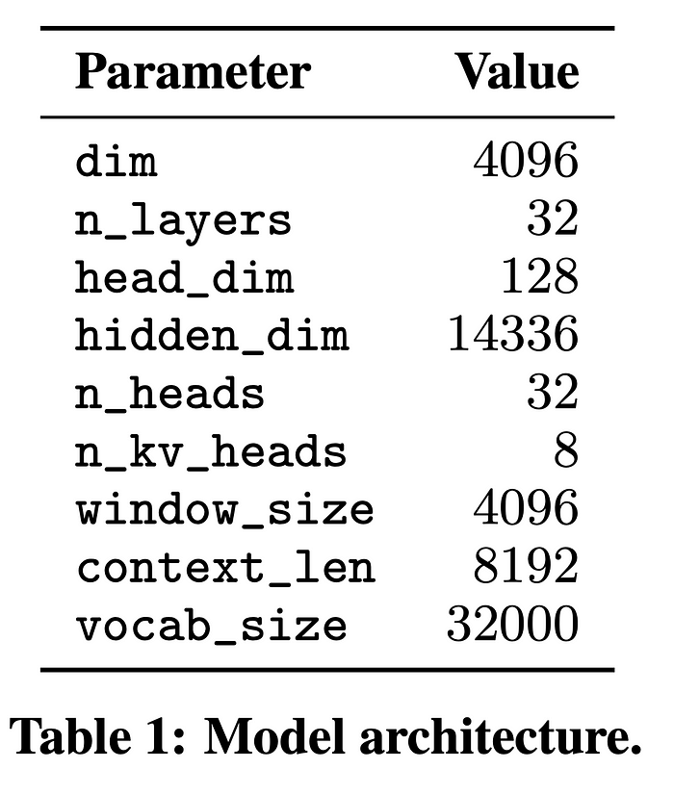

*****Mistral 7B enhances the traditional transformer model architecture, which is detailed in Table 1, with innovative changes to improve efficiency and extend the model’s attention span while managing computational resources more effectively.*****

# **Cost and Accessibility: LLaMa 3 vs. Mistral 7B**

## **LLaMa 3 (70B) Cost and Accessibility:**

* ****Affordable Pricing:****LLaMa 3 (70B) offers a competitive price of $0.93 per 1 million tokens, with specific prices of $0.90 for input tokens and $1.00 for output tokens.
* ****Open-Source Advantage:**** Being open-source, LLaMa 3 does not involve any licensing fees, making it accessible to a wide range of users from academia to startups. This openness encourages widespread experimentation and development, enhancing practical engagement with cutting-edge AI tools.
* ****Community Collaboration:**** The open-source nature also supports a community-driven approach, allowing developers and researchers to contribute to its ongoing enhancement and growth.

# **Mistral 7B Cost-Effectiveness and User-Friendly Deployment:**

* ****Cost-Effective Model:**** Mistral 7B uses a usage-based pricing model that can significantly reduce costs. For instance, TurboDoc was able to cut its AI-related costs by over 65% after switching to Mistral 7B through the AIML API.
* ****Competitive Pricing:**** For every 1,000 tokens, Mistral 7B charges only $0.00045, making it more cost-effective compared to other models like GPT-3.5-turbo, which charges $0.0015 to $0.0040 per 1,000 tokens, depending on the context.
* ****Ease of Use:**** Mistral 7B is designed to be easy to deploy and scale, making it suitable for both small startups and large enterprises looking to enhance their AI capabilities.

# **Use Cases and Applications: LLaMa 3 vs. Mistral 7B**

## **LLaMa 3 Use Cases and Applications:**

* ****Advanced Research:**** LLaMa 3’s extensive capabilities make it ideal for academic and industrial research, where deep understanding and complex reasoning are required.
* ****Language Understanding and Generation:**** Thanks to its improved model performance and diverse training, it excels in tasks involving multiple languages and complex linguistic structures, such as translating documents or generating content in various styles and tones.
* ****Code Generation and Review:**** With enhanced coding data in its training, LLaMa 3 is well-suited for software development tasks such as automating code generation, debugging, or even teaching programming concepts.
* ****Creative Applications:**** Artists and writers can use LLaMa 3 to generate creative content, from poetry and storytelling to conceptual art descriptions.

## **Mistral 7B Use Cases and Applications:**

* ****Enterprise Solutions:**** Mistral 7B is designed to be highly efficient, making it suitable for enterprise applications where speed and cost-effectiveness are crucial, such as real-time customer support bots or transactional data processing.
* ****Content Moderation:**** It includes built-in mechanisms for content moderation, making it useful for platforms needing to filter and classify user-generated content accurately.
* ****Data Extraction and Analysis:**** As demonstrated by applications like TurboDoc, Mistral 7B excels in extracting and organizing data from unstructured sources, which is beneficial for businesses handling large volumes of documents like invoices, receipts, or legal contracts.
* ****Educational Tools:**** Mistral 7B can be tailored to develop educational software that assists in tutoring, especially in subjects requiring problem-solving and logical reasoning.

# ****What’s Next for LLaMa 3 and Mistral 7B?****

## **Future Developments for LLaMa 3:**

* ****Upcoming Releases:**** Meta plans to release larger versions of LLaMa 3, with models exceeding 400 billion parameters, introducing significant enhancements.
* ****New Capabilities:**** These future models will include features like multimodality, the ability to handle multiple languages more effectively, a longer context window, and overall stronger capabilities.
* ****Ongoing Research:**** Meta is currently preparing a detailed research paper to share once the training of the largest LLaMa 3 models is complete.
* ****Early Insights:**** Preliminary data from these training sessions suggest promising trends in the capabilities of these advanced models, though they have yet to be available in the current release.

## **Potential Enhancements for Mistral 7B:**

* ****Efficiency Improvements:**** Mistral AI aims to enhance the Grouped Query Attention (GQA) mechanism to boost efficiency further, making the model even more suitable for less powerful devices.
* ****Accessibility and Community Development:**** Plans include making Mistral 7B available on more platforms like Hugging Face, fostering a diverse community of developers, and encouraging more experimentation.

## **Future Prospects for LLaMa-2 7B:**

* ****Emotional Intelligence in Dialogue:**** Researchers are exploring ways to advance the model’s ability to understand and process emotions in conversations, enhancing its applicability in interactive applications.
* ****Multimodal Capabilities:**** There is also a focus on expanding the model’s capabilities to handle both text audio and visual inputs, broadening its utility across different media.

## **Conclusion:**

****Both LLaMa 3 and Mistral 7B, along with LLaMa-2 7B, are poised for significant advancements.**** These developments are expected to open new avenues for research and practical applications, ensuring that these models remain at the forefront of the AI field. The ongoing improvements signify a continuous evolution towards more powerful, versatile, and accessible language models.